 | Sanjivani Rural Educational Society’s  SANJIVANI COLLEGE OF ENGINEERING  (An Autonomous Institution)  Kopargaon – 423 603, Maharashtra. | ACAD-F-15  K
Academic Year:  2025-26 | CIA ACTIVITY REPORT | Revision: 00 Dated:
Department: Information Technology | Information Technology | Date of Preparation:  19-4-26
Course Code & Name: | PCIT208: Software Engineering Modeling & Design | Year/Sem: II  B.Tech Sem-IV

Activity Title: Smart Campus Management System

Submitted by:

Roll No | PRN No | Name | Signature
114 | 0124UITM1114 | Sanket Babasaheb Walke
115 | 0124UTM1115 | Ramkrushn Sharad Kadam
117 | 0124UITM1117 | Kiran Navnath Dhage
118 | 0124UITM1118 | Manoj Sanjay Shelke

Course Incharge:
Dr. S. N. Gunjal

INDEX
Sr.No. | Topic | Page no.
1. | Abstract | 03
2. | Project Definition | 04
3. | Introduction | 05
4. | Scope of the Project | 06
5. | Objectives of the Project | 07
6. | Literature Review / Background Study | 08
7. | System Analysis  7.1 Existing System  7.2 Problems in Existing System  7.3 Proposed System | 09
8. | Software Requirements Specification (SRS)  8.1 Functional Requirements  8.2 Non-Functional Requirements  8.3 Use Case Diagram  8.4 Use Case Description | 10-16
9. | System Design  9.1 UML Diagrams  - Class Diagram  - Sequence Diagram  - Activity Diagram  - Sate chart Diagram  - Collaboration Diagram  - Component Diagram  - Deployment Diagram | 17-25
10. | Data Flow Diagram (DFD) | 26
11. | Control Flow Diagram(CFD) | 27
12. | Conclusion | 28
13. | References | 29

Abstract

Education institutions handle many activities such as student record management, attendance tracking, fee processing, academic monitoring, communication, and resource management. In traditional campus systems, these tasks are often managed manually using paper-based records, spreadsheets, and offline communication, which can lead to data loss, time consumption, human errors, and lack of transparency. Although the conventional system is simple and widely used, it faces issues like inefficiency, delayed updates, difficulty in accessing information, and poor coordination between students, faculty, and administration.
To overcome these limitations, a Smart Campus Management System is proposed. This system provides a centralized, web-based platform that enables efficient digital management of campus operations. It includes features such as student and faculty management, attendance tracking, fee management, timetable scheduling, notifications, and performance monitoring. By integrating modern technologies, the system improves accuracy, enhances communication, and supports better decision-making within the institution.

Project Definition

In the modern education system, effective campus management is essential for ensuring smooth academic and administrative operations. Traditional campus management methods rely heavily on manual processes such as maintaining student records, tracking attendance, managing fees, and handling communication. These methods are time-consuming, error-prone, and lack real-time accessibility and proper coordination.
The Smart Campus Management System provides a digital solution by integrating various campus activities into a single platform. It enables administrators and faculty to manage operations efficiently while allowing students to access information anytime. This system enhances productivity, reduces paperwork, improves communication, and ensures better management of the overall educational environment.

Introduction

In the modern education system, effective campus management is essential for the smooth functioning of academic and administrative activities. Traditional campus management methods rely heavily on manual processes such as maintaining student records, tracking attendance, managing fees, and handling communication. These methods are time-consuming, error-prone, and lack proper coordination and real-time access to information.
The Smart Campus Management System provides a digital solution by integrating all campus activities into a single platform. It enables administrators and faculty to manage operations efficiently while allowing students to access information anytime and from anywhere. This system enhances productivity, reduces paperwork, improves communication, and ensures better management of the overall educational environment.

Scope Of Project

- The system supports student registration, attendance, and academic management.
- It can be used by students, faculty, and administrators across the campus.
- The system provides real-time updates, notifications, and communication.
- It securely stores academic and administrative records for future use.
- It improves transparency, organization, efficiency, and overall campus productivity.

Objectives of Project

- To develop an online platform for managing campus operations.
- To maintain student, faculty, and attendance records digitally.
- To simplify fee management, academic tracking, and report generation.
- To improve communication between students, faculty, and administration.
- To reduce manual work and increase efficiency in campus management

Literature Review / Background Study

Campus management has traditionally been carried out using manual methods such as maintaining student records, tracking attendance, managing fees, and handling academic activities through paper-based systems. These methods are simple but often lead to inefficiency, data redundancy, errors, and difficulty in maintaining and retrieving records over time. Communication between students, faculty, and administration is also limited and delayed in such systems.
With the advancement of technology, various digital solutions such as Campus Management Systems, Enterprise Resource Planning (ERP) systems, and educational software have been introduced. These systems provide features like online attendance, digital record management, fee processing, and performance tracking. They help improve accessibility, reduce manual effort, and enable better communication across the institution.
However, many existing systems are either complex, costly, or not fully integrated, making them unsuitable for all educational institutions. Some systems focus only on specific modules and fail to provide a complete solution for managing all campus activities.
The Smart Campus Management System is developed to overcome these limitations by offering a simple, user-friendly, and integrated platform. It combines essential campus functions such as student and faculty management, attendance tracking, fee management, academic monitoring, and communication into a single system, ensuring efficient and effective campus management.

System Analysis

System Analysis is the process of studying the current system, identifying its limitations, and proposing an improved solution. It helps in understanding system requirements and designing an efficient and effective system.
7.1 Existing System
The existing campus management system is mostly manual and paper-based. Student records are maintained in files or registers, attendance is recorded manually, fees are processed offline, and academic activities are handled separately. Communication between students, faculty, and administration is often done through notices or verbal methods.
There is no centralized digital platform, making it difficult to store, manage, and retrieve data efficiently.

7.2 Problems in Existing System
The traditional system has several limitations:
- Time-consuming and inefficient processes
- High chances of human errors in records and calculations
- Difficulty in maintaining and storing large amounts of data
- Lack of real-time updates and accessibility
- Poor communication between students, faculty, and administration
- No proper tracking of academic performance
- Risk of data loss or damage

7.3 Proposed System
The proposed Smart Campus Management System provides a digital solution to overcome these limitations. It is a web-based platform that automates and integrates campus operations.
The system includes features such as:
- Online student and faculty registration/login
- Digital attendance management
- Fee management and tracking
- Academic and result management
- Timetable scheduling
- Notification and communication system
- Secure database for storing campus data

This system reduces manual work, improves accuracy, provides real-time access to information, and ensures efficient and organized campus management.

Requirements Specification (SRS)

The Software Requirements Specification (SRS) defines the functional and non-functional requirements of the Smart Campus Management System. It describes how the system should operate and the constraints under which it functions.

8.1 Functional Requirements
Functional requirements describe what the system should do:
- The system shall allow users (students, faculty, admin) to register and login
- The system shall manage student and faculty information and records
- The system shall record and maintain attendance digitally
- The system shall manage fee collection and payment records
- The system shall handle academic activities such as assignments and results
- The system shall generate and display reports and results
- The system shall send notifications and updates to users
- The system shall allow administrators to manage campus operations
- The system shall store and retrieve data from a centralized database

8.2 Non-Functional Requirements
Non-functional requirements define system performance and quality:
- Performance: The system should respond quickly to user requests
- Security: Only authorized users should access the system
- Usability: The system should be user-friendly and easy to operate
- Reliability: The system should function without failures
- Scalability: The system should support multiple users simultaneously
- Availability: The system should be accessible whenever required
- Maintainability: The system should be easy to update and maintain

8.3 Use Case Diagram
The Use Case Diagram represents the interaction between users and the Smart Campus Management System. It shows functionalities such as login, student and faculty management, attendance, academic activities, and communication performed by Admin, Faculty, Student, and Visitor.
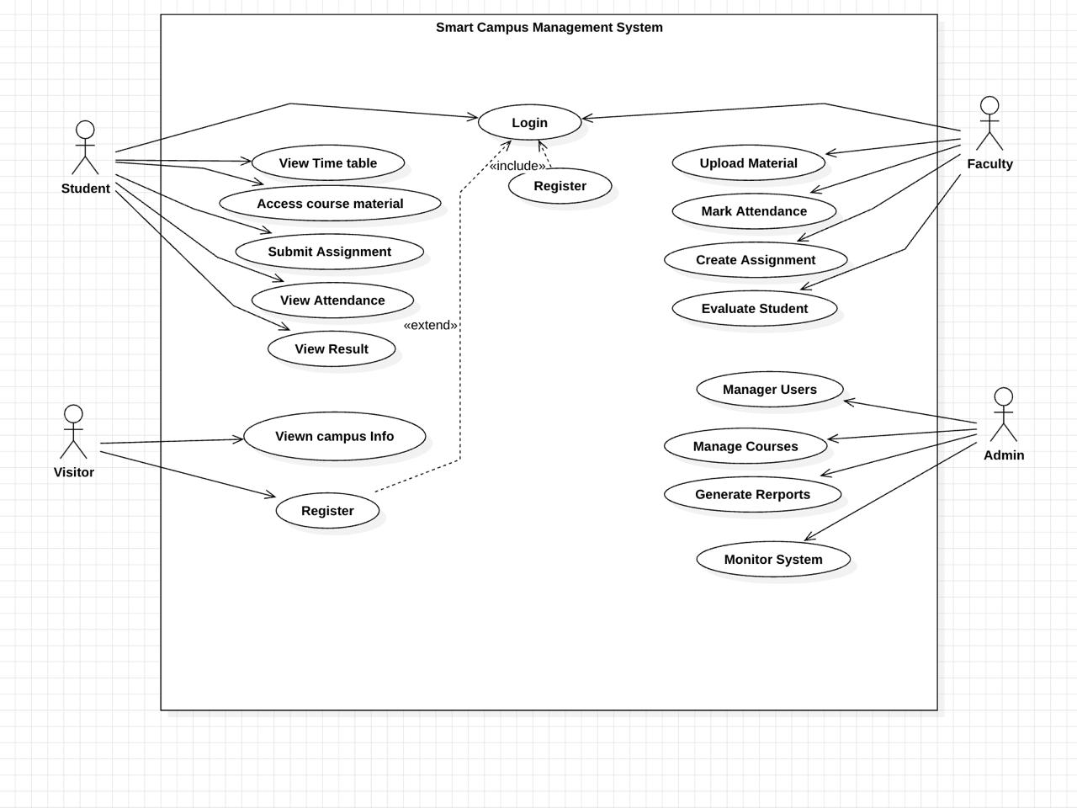
8.4 Use Case Description (As per Diagram)
Use Case: Login
Actor: Admin, Faculty, Student, Visitor
Description: User logs into the system using credentials
Pre-condition: User must be registered
Post-condition: User gets access to system
Flow:
- User enters username and password
- System validates details
- If valid → access granted
- If invalid → error message displayed

- Student Use Cases
Use Case: View Timetable
Actor: Student
Description: Student views class timetable
Flow:
- Student selects timetable
- System displays schedule

Use Case: Access Course Materials
Actor: Student
Description: Student accesses study materials
Flow:
- Student selects course materials
- System displays content

Use Case: Submit Assignments
Actor: Student
Description: Student submits assignments
Flow:
- Student selects assignment
- Uploads file
- Confirms submission

Use Case: View Attendance
Actor: Student
Description: Student views attendance records
Flow:
- Student selects attendance
- System displays attendance

Use Case: View Results
Actor: Student
Description: Student views results
Flow:
- Student selects results
- System displays marks

- Faculty Use Cases
Use Case: Upload Study Materials
Actor: Faculty
Description: Faculty uploads learning resources
Flow:
- Faculty selects upload option
- Uploads material
- System stores it

Use Case: Mark Attendance
Actor: Faculty
Description: Faculty records student attendance
Flow:
- Faculty selects class
- Marks attendance
- Saves attendance

Use Case: Create Assignments
Actor: Faculty
Description: Faculty creates assignments
Flow:
- Faculty selects assignment option
- Creates assignment
- System publishes it

Use Case: Evaluate Students
Actor: Faculty
Description: Faculty evaluates student performance
Flow:
- Faculty checks submissions
- Assigns marks
- System updates results

- Admin Use Cases
Use Case: Manage Users
Actor: Admin
Description: Admin manages students and faculty
Flow:
- Admin selects manage users
- Performs add/update/delete
- System updates database

Use Case: Manage Courses
Actor: Admin
Description: Admin manages courses
Flow:
- Admin selects courses
- Performs required operation
- System updates records

Use Case: Generate Reports
Actor: Admin
Description: Admin generates reports
Flow:
- Admin selects report type
- System generates report

Use Case: Monitor System
Actor: Admin
Description: Admin monitors system performance
Flow:
- Admin checks dashboard
- System displays status

- Visitor Use Cases
Use Case: View Campus Info
Actor: Visitor
Description: Visitor views campus information
Flow:
- Visitor selects campus info
- System displays details

Use Case: Register
Actor: Visitor
Description: Visitor registers into the system
Flow:
- Visitor enters details
- System validates
- Account is created

9.System Design
System Design describes the overall structure and working of the Smart Campus Management System using different UML diagrams. These diagrams help in understanding the system behavior, structure, and interaction between various components.

9.1 UML Diagrams
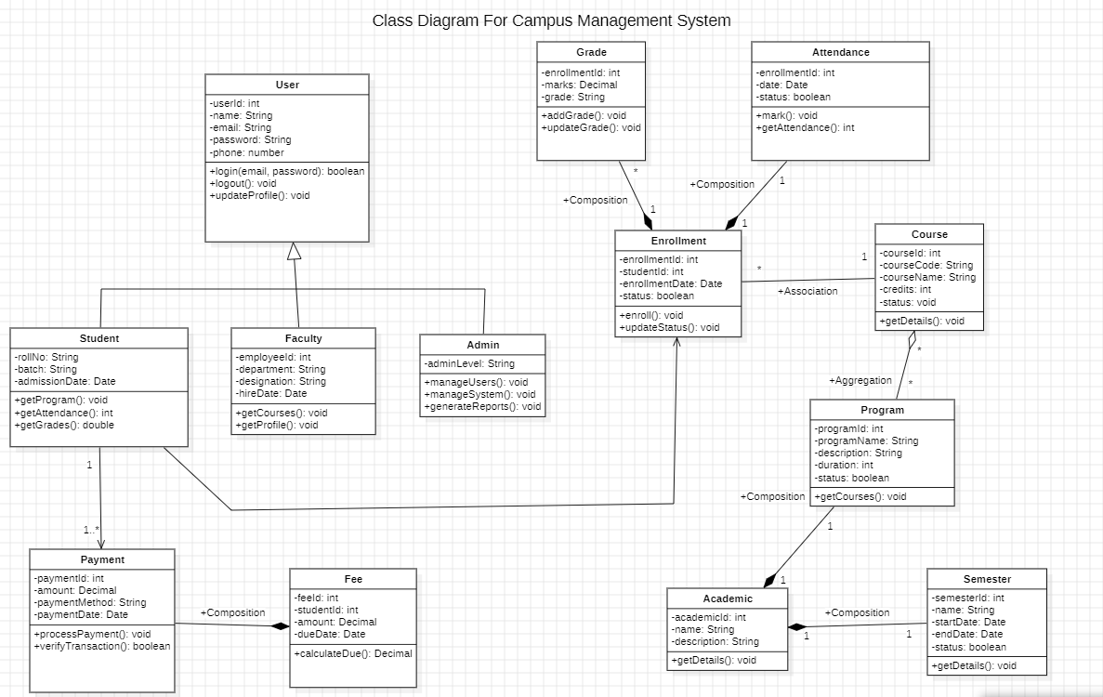
- Class Diagram
The Class Diagram represents the static structure of the system. It shows different classes such as Student, Faculty, Admin, Course, Assignment, Attendance, Fee, and Result along with their attributes and relationships. It helps in understanding how data is organized and managed within the system.

Sequence Diagram
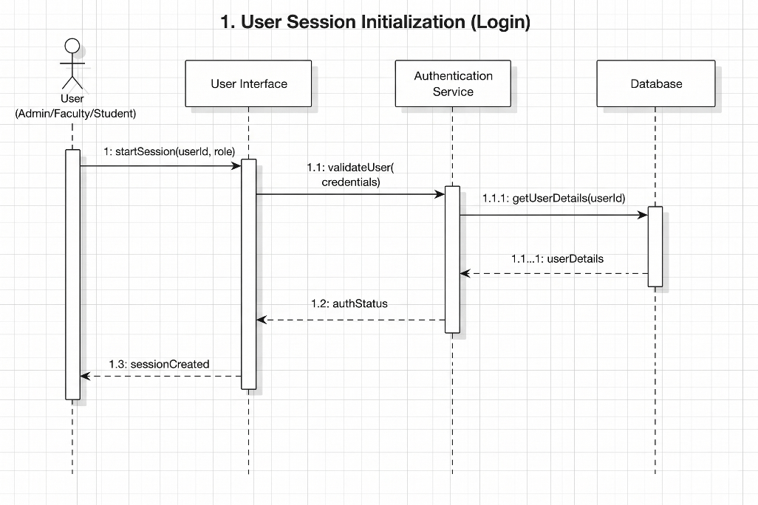
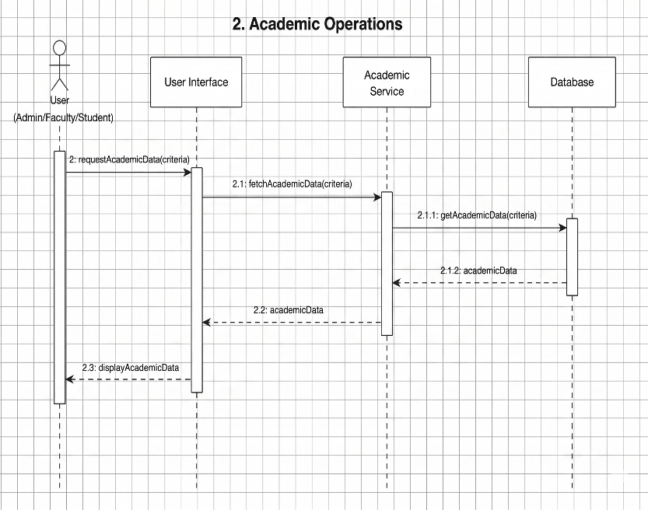
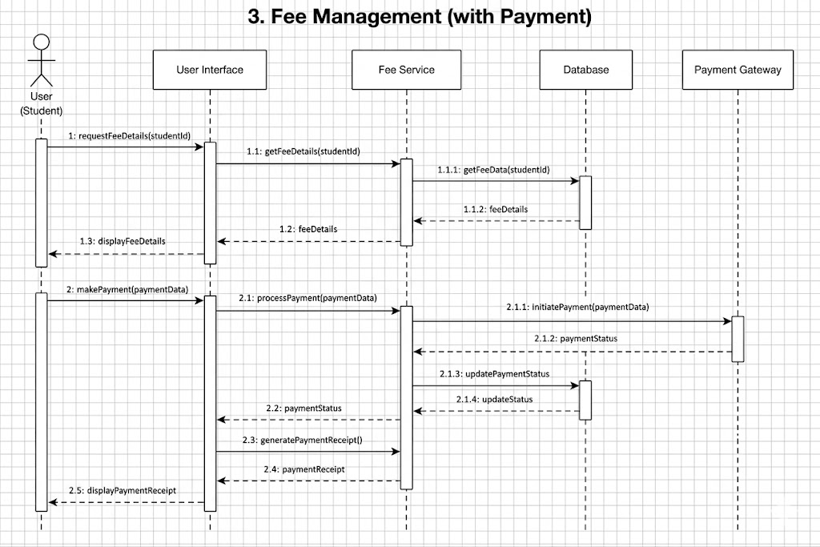
The Sequence Diagram shows the interaction between different components of the Smart Campus Management System in a time sequence. It represents how messages are exchanged between users and the system during operations such as login, attendance management, assignment submission, and result viewing.
It illustrates the flow of actions between actors (Admin, Faculty, Student) and system modules, helping to understand how processes are executed step-by-step within the system.

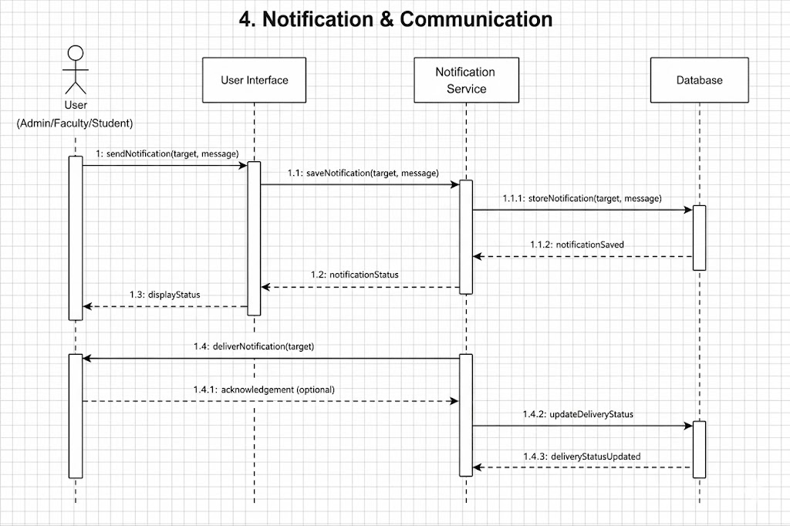
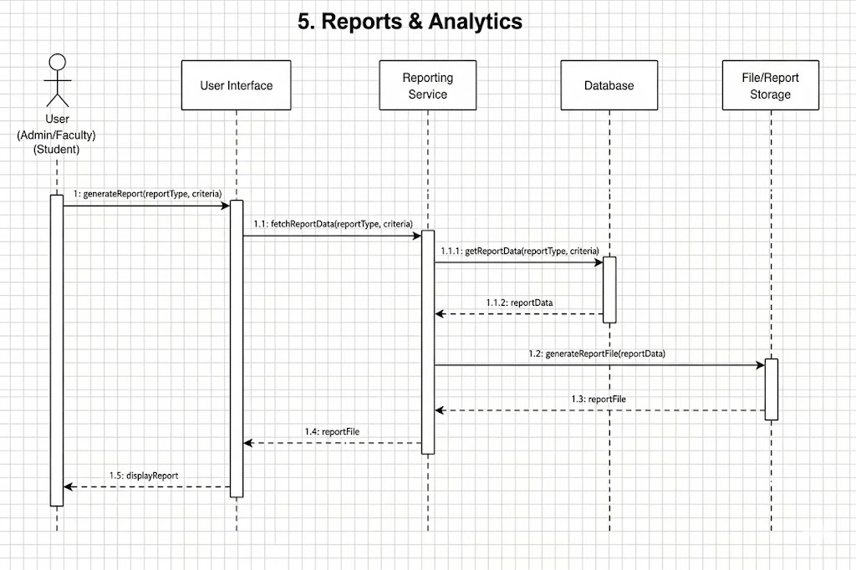
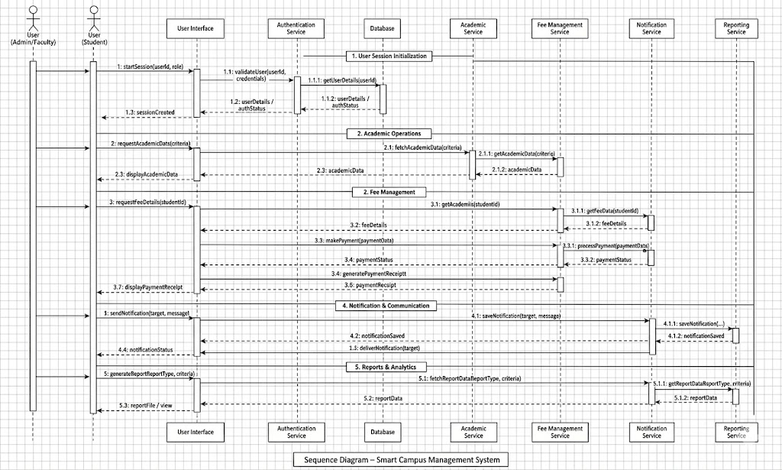

Activity Diagram
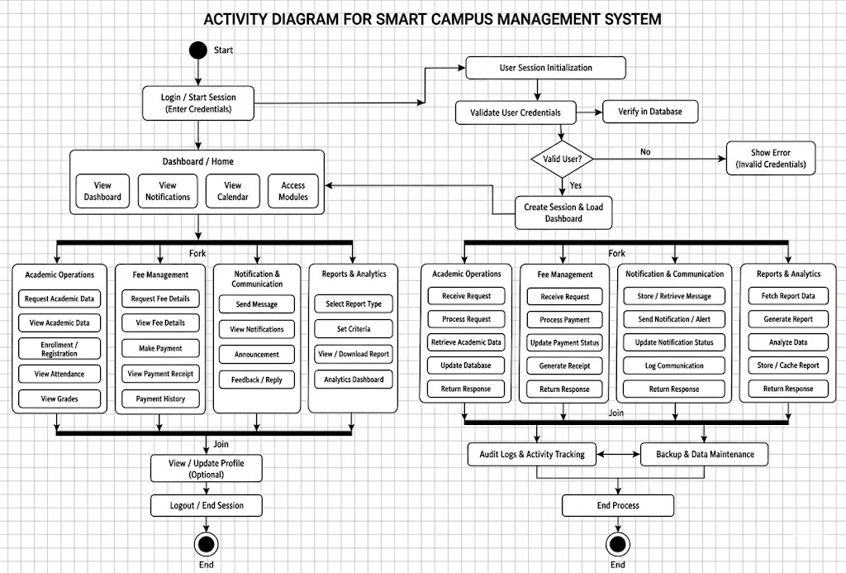
The Activity Diagram represents the flow of activities in the Smart Campus Management System. It shows the step-by-step process of operations such as user login, validation, selecting modules (like student management, attendance, fees, or assignments), performing actions, and generating responses .It helps in understanding the workflow of the system and how different activities are executed in sequence to complete a task efficiently.

State Chart Diagram
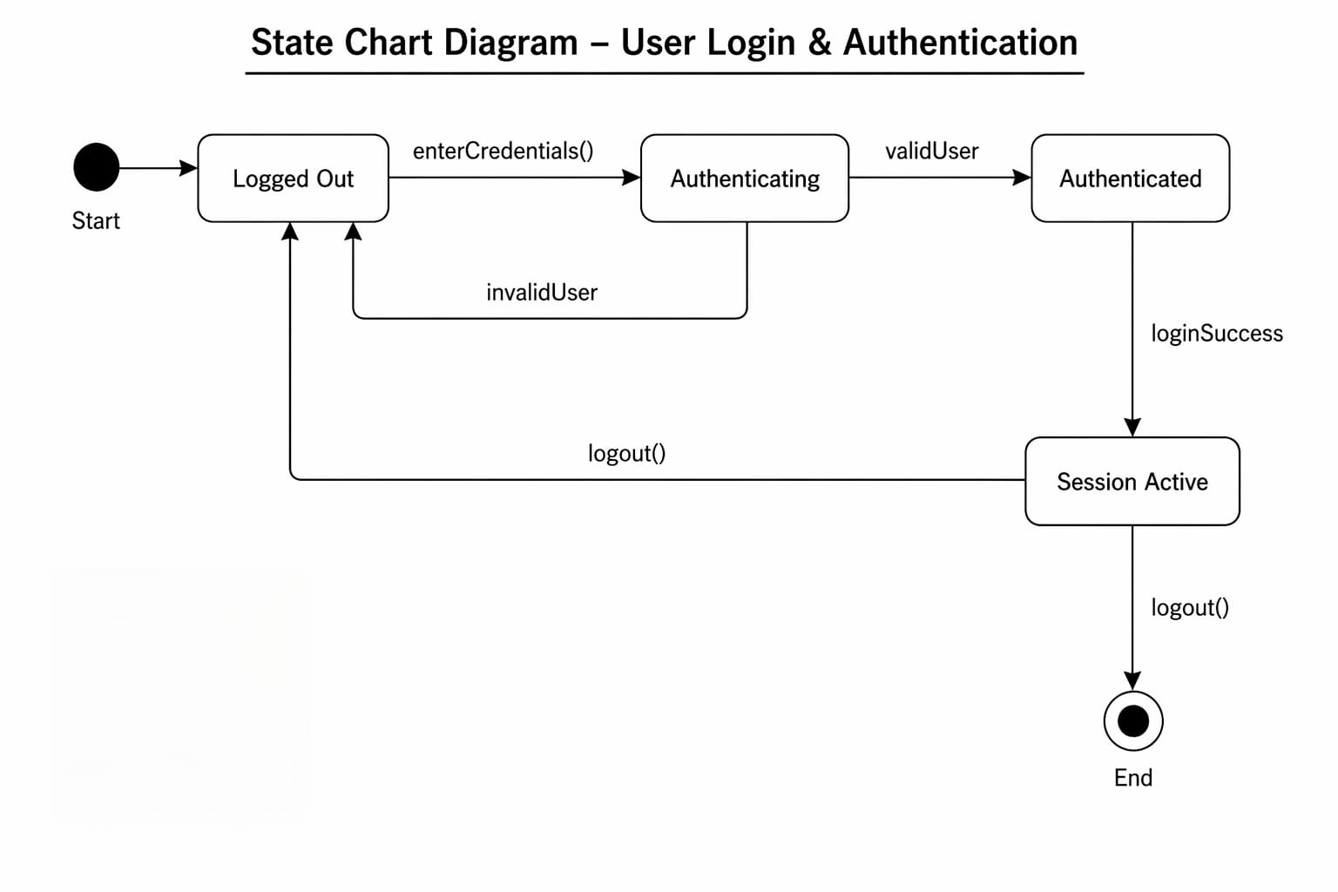
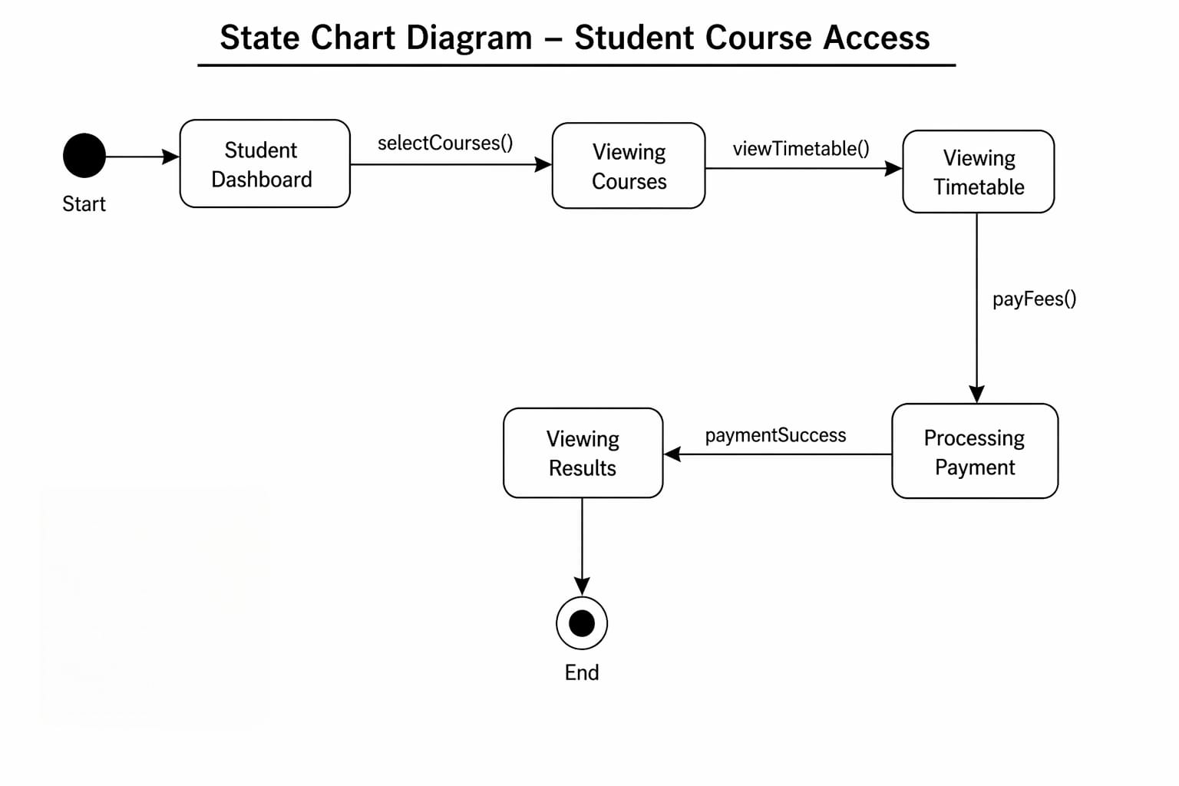
The State Chart Diagram represents the different states of the Smart Campus Management System and the transitions between them. It includes states such as login state, validation state, dashboard state, and action states like student management, course management, timetable management, and report generation.
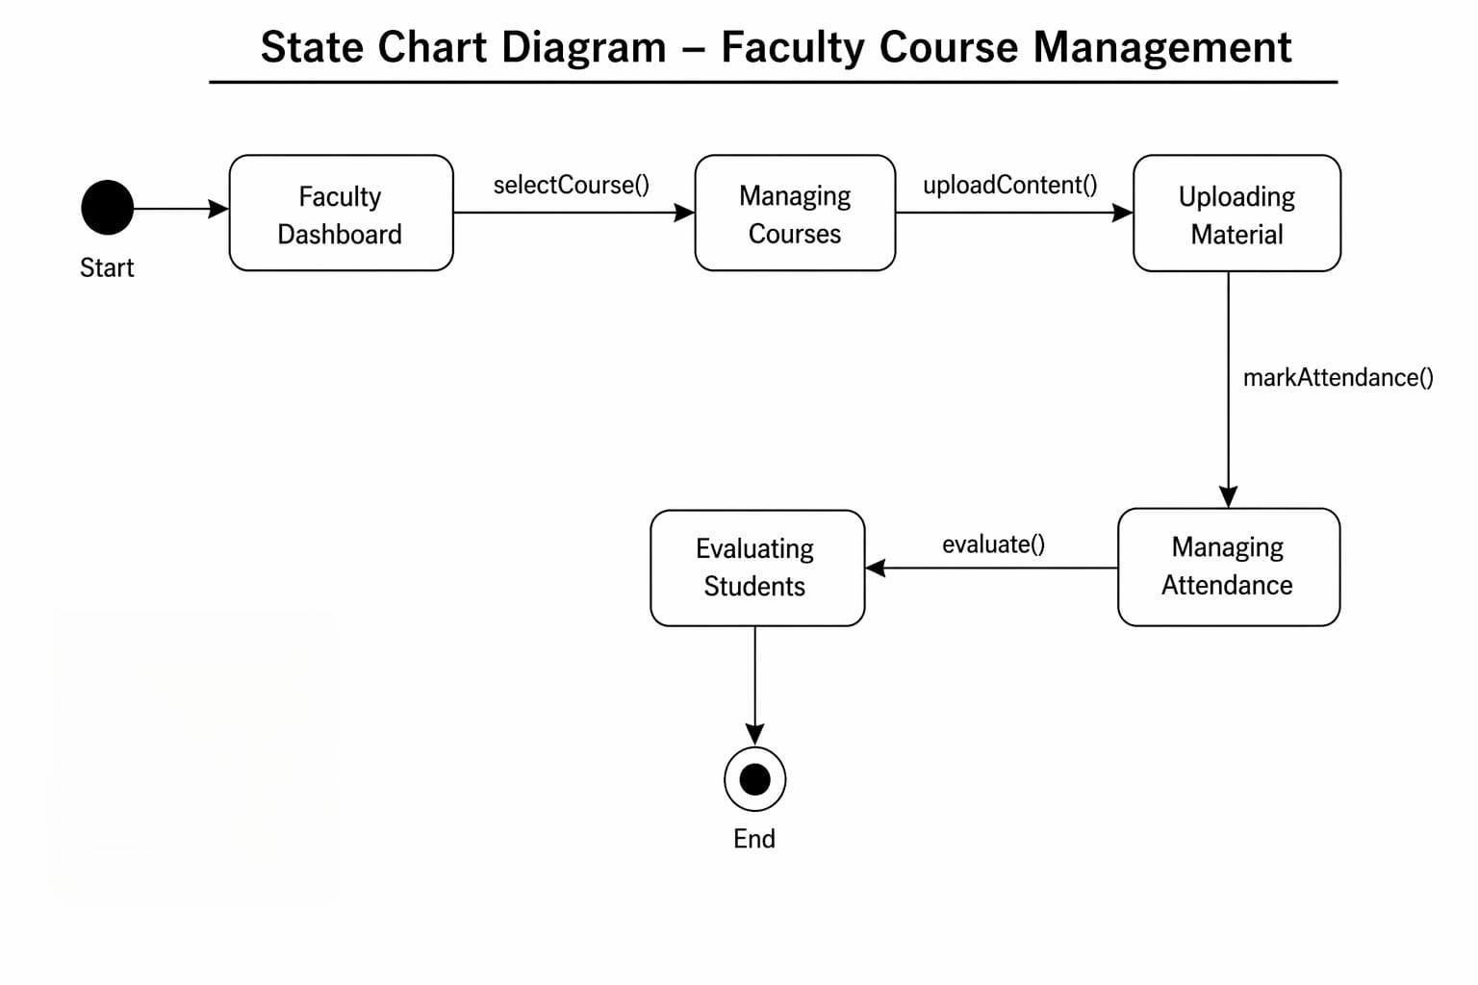
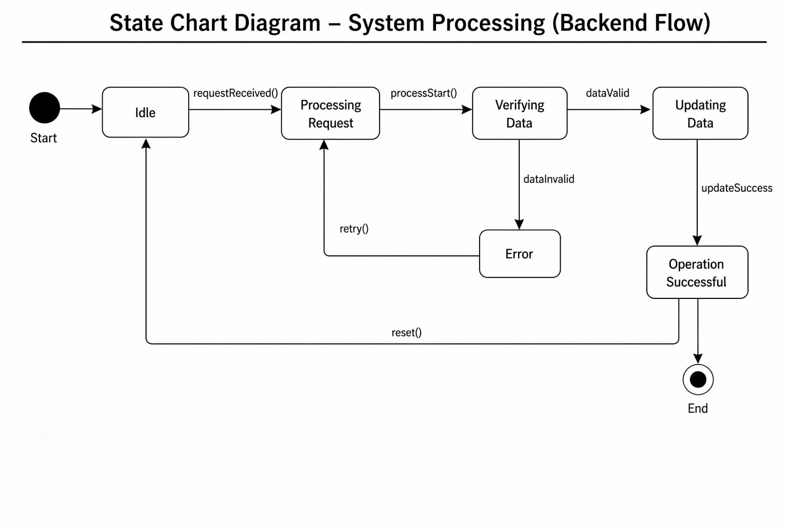
Collaboration Diagram

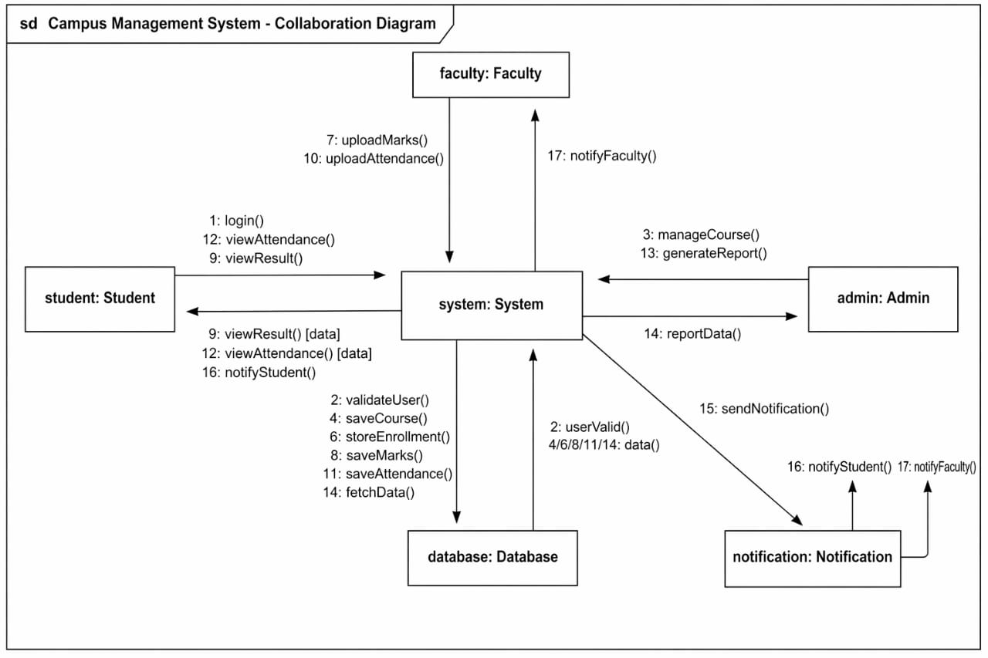
The Collaboration Diagram shows how different objects interact and collaborate with each other to perform a task. It focuses on relationships and communication between system components.

Component Diagram
The Component Diagram represents the different modules of the Smart Campus Management System such as User Interface, Authentication Module, Student Management Module, Faculty Management Module, Course Management Module, Fee Management Module, and Database. It shows how these components are connected and interact with each other to perform various campus operations.

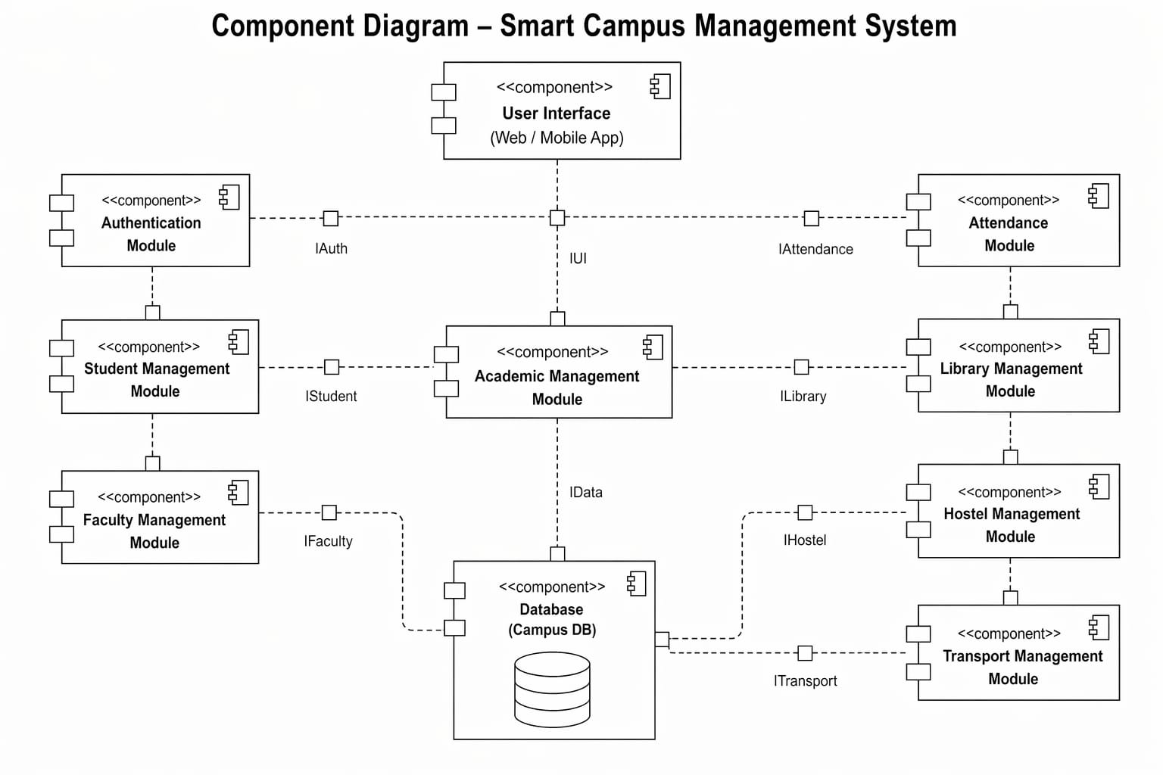
Deployment Diagram
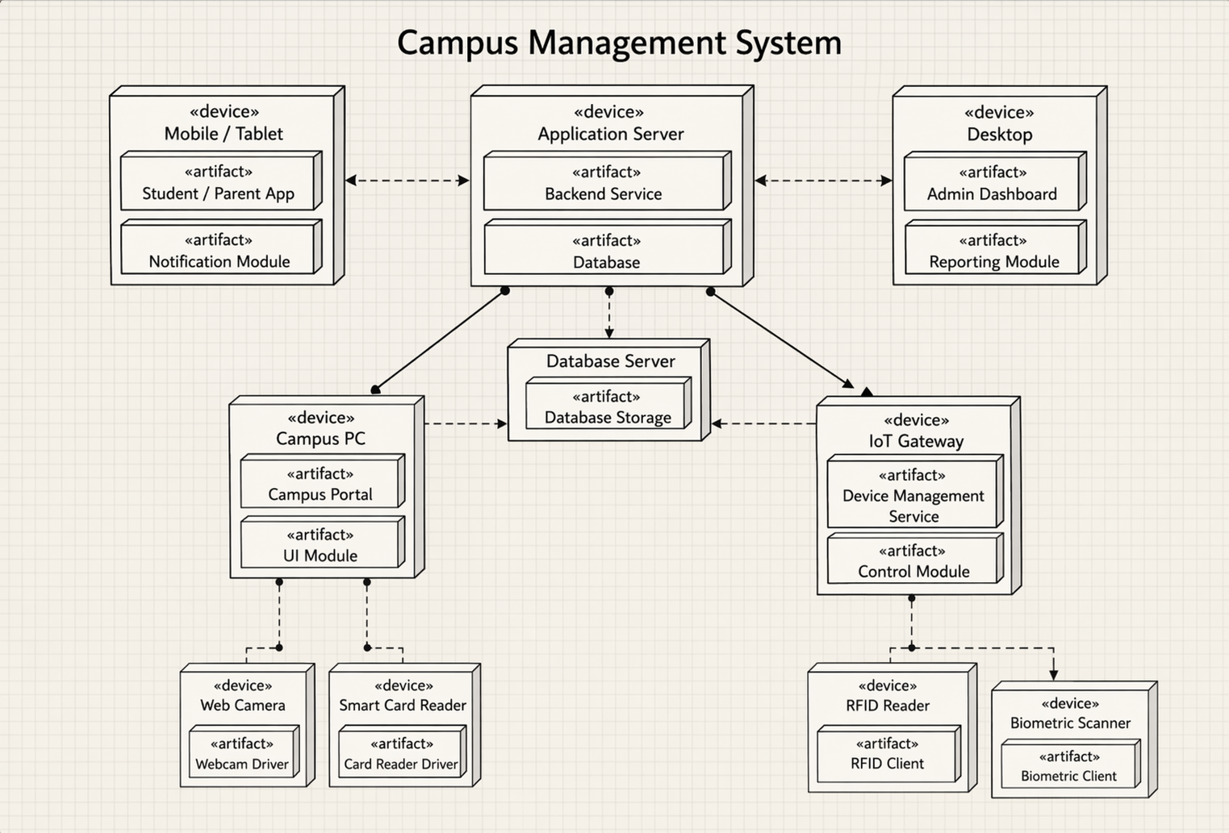
The Deployment Diagram shows the physical structure of the system. It represents hardware components such as client devices, server, and database, and how they are connected through a network.

Data Flow Diagram (DFD)

The Data Flow Diagram represents the flow of data within the Smart Campus Management System. It shows how data moves between external entities, processes, and data stores.
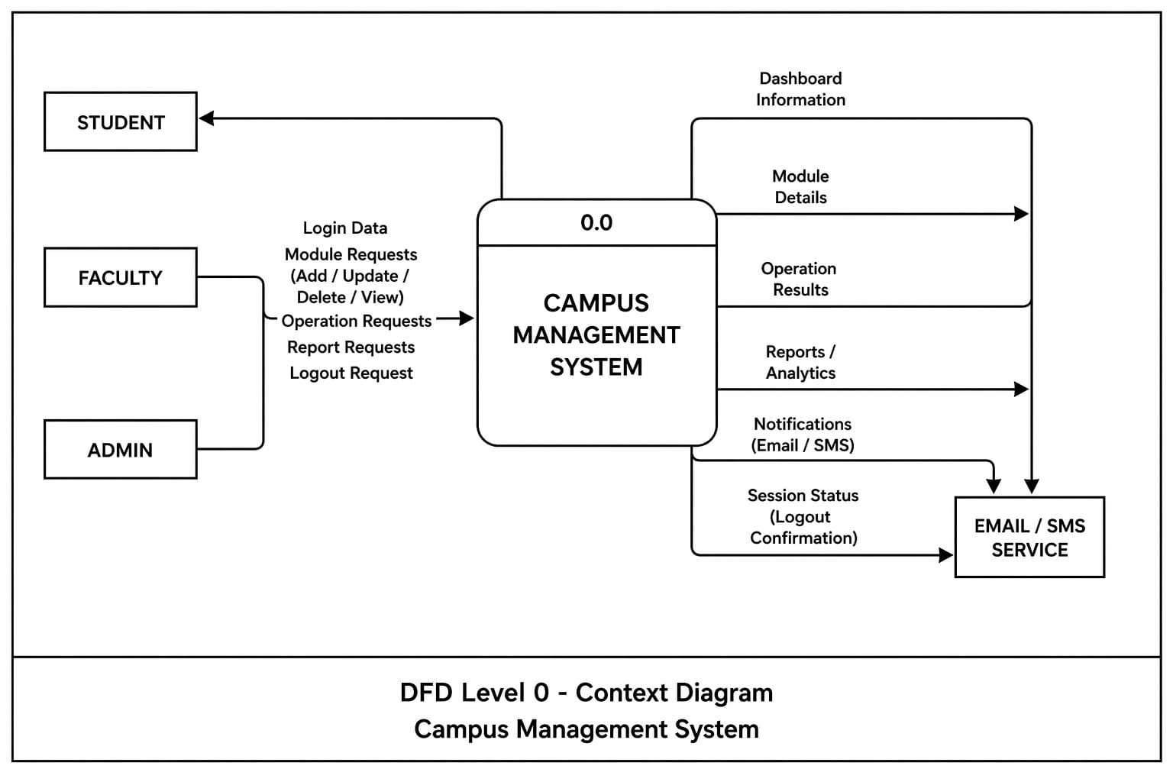
Level:-0
Shows the entire system as a single process interacting with Student, Faculty, Admin, and Visitor.
Level:-1
DFD:
Breaks the system into multiple processes such as authentication, student management, course management, timetable management, fee management, and report generation.
DFD helps in understanding how input data is processed and transformed into meaningful output within the system.

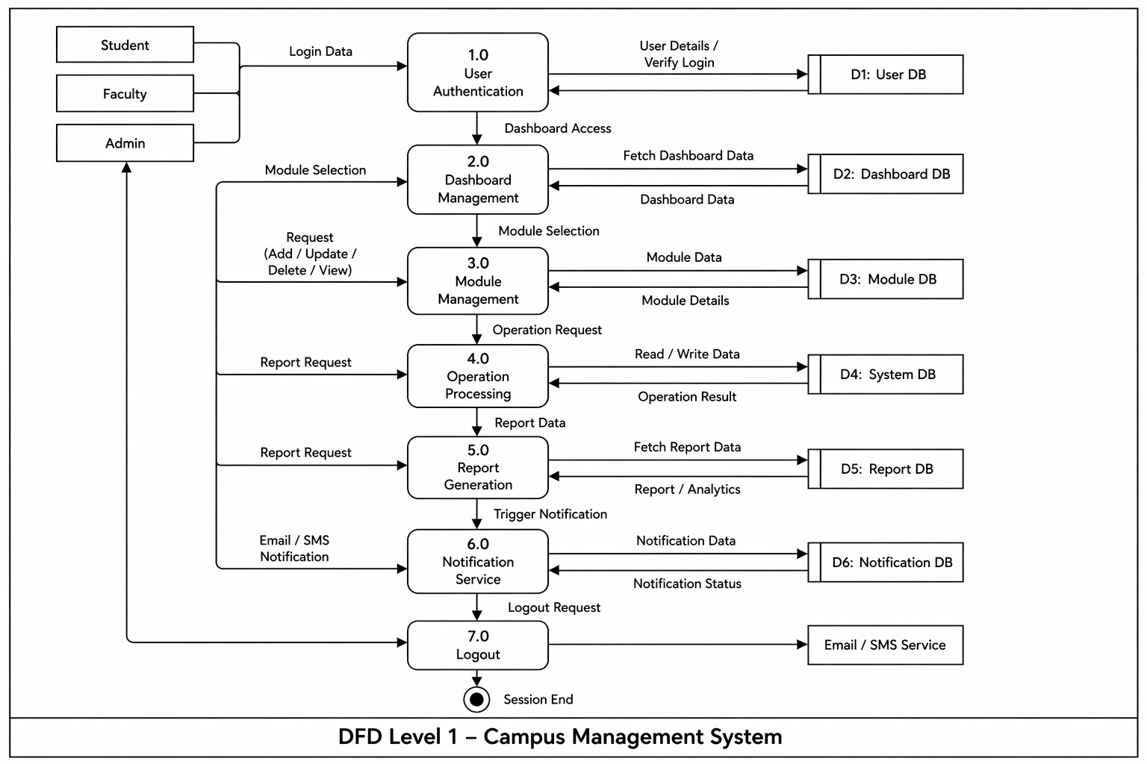

Control Flow Diagram (CFD)

The Control Flow Diagram represents the flow of control in the Smart Campus Management System. It shows the sequence of operations and decision-making steps within the system.
In the Smart Campus Management System, the control flow starts with user login, followed by validation of credentials. Based on validation, the system either grants access or redirects the user back to the login page. After successful login, the user selects an activity such as student management, course management, timetable management, or report generation. The system then performs the selected action, updates the records, and generates the appropriate response.
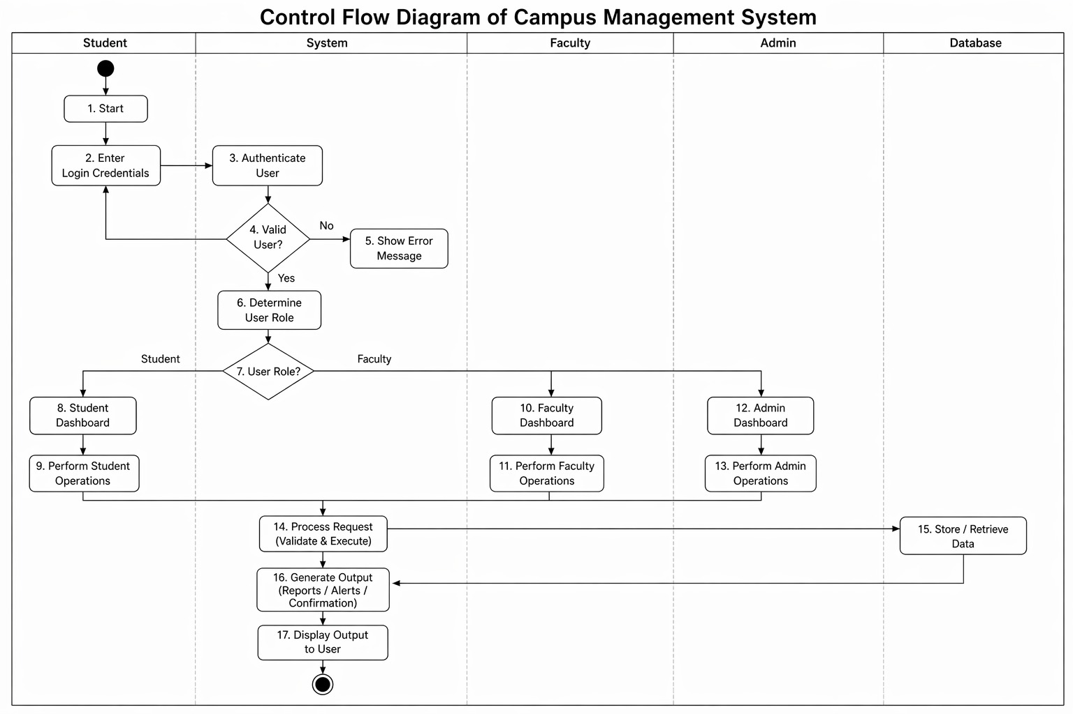
The diagram helps in understanding the logical flow and control structure of the system.

Conclusion

The Smart Campus Management System is an effective solution for modernizing traditional campus operations. It replaces manual processes such as student record handling, attendance tracking, fee management, and academic activities with a digital and automated system. This reduces human effort, minimizes errors, and saves time for both staff and students.
The system provides a centralized platform where all campus activities can be managed efficiently. Features like digital attendance, course management, timetable scheduling, fee tracking, and real-time notifications improve communication and transparency within the institution. It also ensures secure storage and easy retrieval of data, which is difficult in manual systems.
By using this system, administrators and faculty can focus more on core activities rather than administrative tasks, while students can access their academic information anytime and anywhere. The system also helps in better monitoring of overall campus performance and operations.
In conclusion, the Smart Campus Management System enhances efficiency, accuracy, and organization in campus management. It is a reliable and scalable solution that can be implemented in educational institutions to improve overall management and productivity.

13.References

- Software Engineering
- StarUML – Used for creating UML diagrams
- Study material and notes provided by subject teacher
- Online tutorials and resources related to UML diagrams and system design
- Various educational websites for understanding DFD, UML, and software development concepts
- GreeksforGeeks – For understanding DFD, UML diagrams and programming concepts
- W3Schools – For basic development and database concepts

